Directions for Making an Experience Book

WHAT YOU NEED: | LOOKS LIKE THIS:
Two covers (made of cardboard, poster board, or manila file folders) about 6” x 7” with two or three holes punched on the left side.

About five pages of heavy-weight paper (of the same size or slightly smaller than the covers). Old manila file folders work well. | 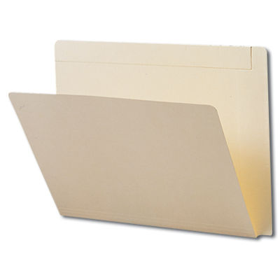
Two or three simple rings to hold books together. | 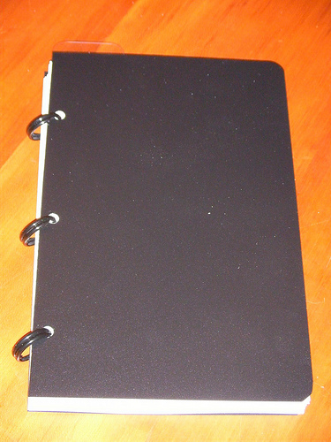  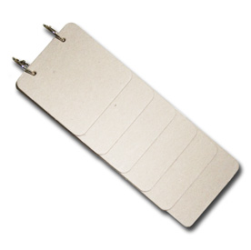
Objects, partial objects, pictures, or photos to go on each page.  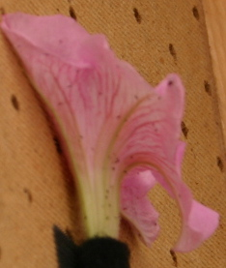  flower | 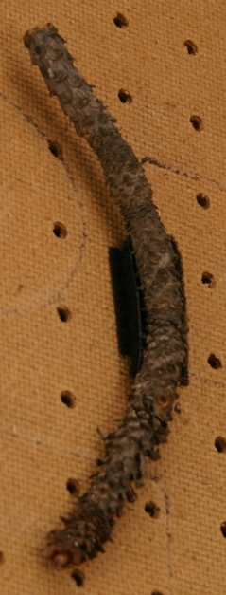  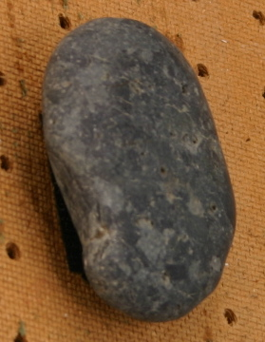  rock twig
Write and/or use braille labeler on each page. Written sentence should be on the cover and each page even if braille is used.  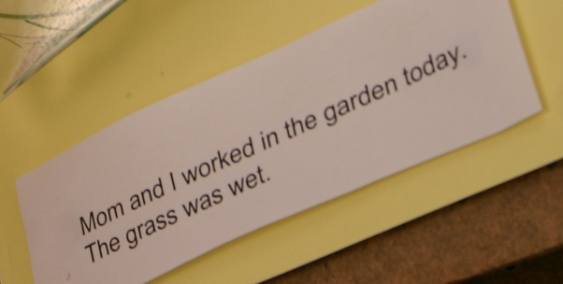 | 

