Family-to-Family Communities Project (F2FC)
Connecting Families of Individuals with Deaf-Blindness via Distance Technology

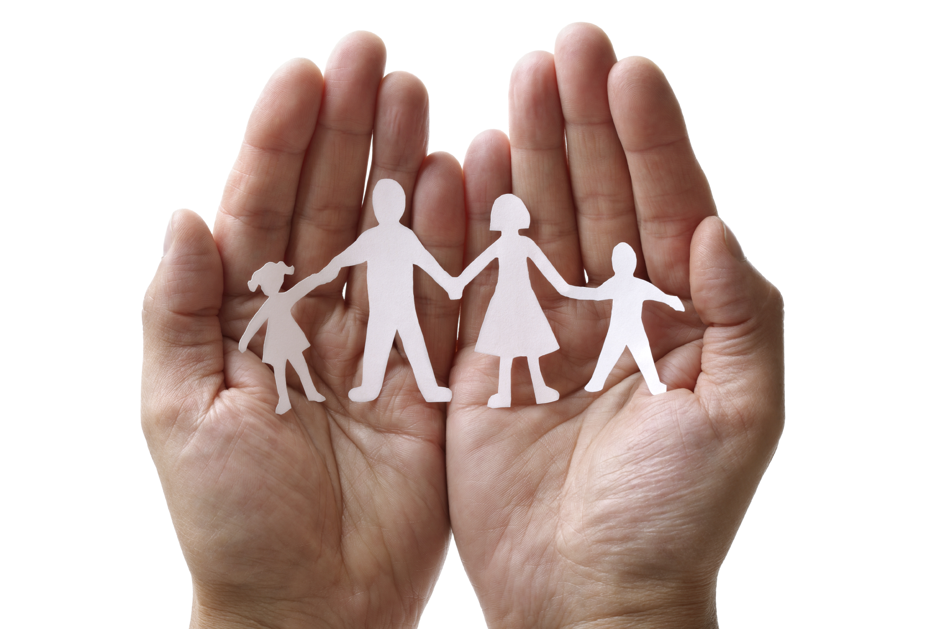
Because deaf-blindness is a rare and diverse disability, families may feel isolated or alone…like there is no one else who understands their experiences.

F2FC offers a unique way for families to connect, share information and resources, offer support to one another, and just talk to someone who “gets it.”

F2FC is open to all families, regardless of the age or diagnosis of your family member, because you share similar challenges and triumphs in the journey of supporting your family member with deaf-blindness.

Family-to-Family Communities Project Format:
- Each F2FC is comprised of 8-10 families with shared commonalities and is guided by trained Facilitators.
- F2FC groups meet once per month for 90 minutes, via phone and/or video conference (group preference).
- Topics are chosen by the group and include a combination of structured conversation and open sharing.
- These are not drop-in calls; your regular participation is vital to the group.
Family-to-Family Communities Project 2018-2019 Groups (adjust for your time zone)

Schedule may require minor changes based upon group needs. Topics listed are only a sample of potential discussions.
- Self-Care Strategies for Parents (all ages): First Thursday of month at 8:30pm ET; topics include- gratitude practice, relaxation techniques, & self-empowerment; Facilitators- Pam Kissoondyal and Heather Joy Magdelano
- Families of School-Age Children (ages 3-14): Second Monday of month at 8:30pm ET; topics include- communication for your child/family, working with educational team, & self-care strategies; Facilitators- Jackie Dalzell & Jenn Henkle
- Families with Members who have Peroxisomal Disorders (all ages): Third Monday of month at 8:30pm ET; topics include- communication, educational support, & life balance / self-care; Facilitators- Krista Olsen & Katie Sacra
- Families with Members who have Usher syndrome (all ages): Wed. eve (time TBD); topics include- processing the diagnosis, working with educational team, & fostering hope and resilience; Facilitators Pam Aasen & Carly Fredericks
- Transition from School to Adulthood (ages 14-22): Day TBD (Tu, W, or Th) at 1pm ET; topics- self-determination; emotional aspects of the family, & person-centered planning; Facilitators- Lane McKittrick & Djenne Morris
- Transition from School to Adulthood (ages 14-22): First Tuesday of month at 8pm ET; topics- empowering parents to: navigate transition, advocate for their child, & access resources; Facilitators- Ellen Bowman & Diane Foster
- Adult Life (age 22+): Last Wednesday of month at 7pm ET; topics include- adult service systems, employment, & housing; Facilitators- Diana Griffen, Jacqueline Izaguirre, & Patti McGowan

Registration is open during June-July 2018 https://gsap.wufoo.com/forms/f2fc-registration-20182019/

Facilitators will contact participants in August 2018. Monthly calls will be held September 2018 to May 2019.

Questions??? Contact Carol Darrah, cdarrah@uga.edu / (706) 542-2433, or your state deaf-blind project.

