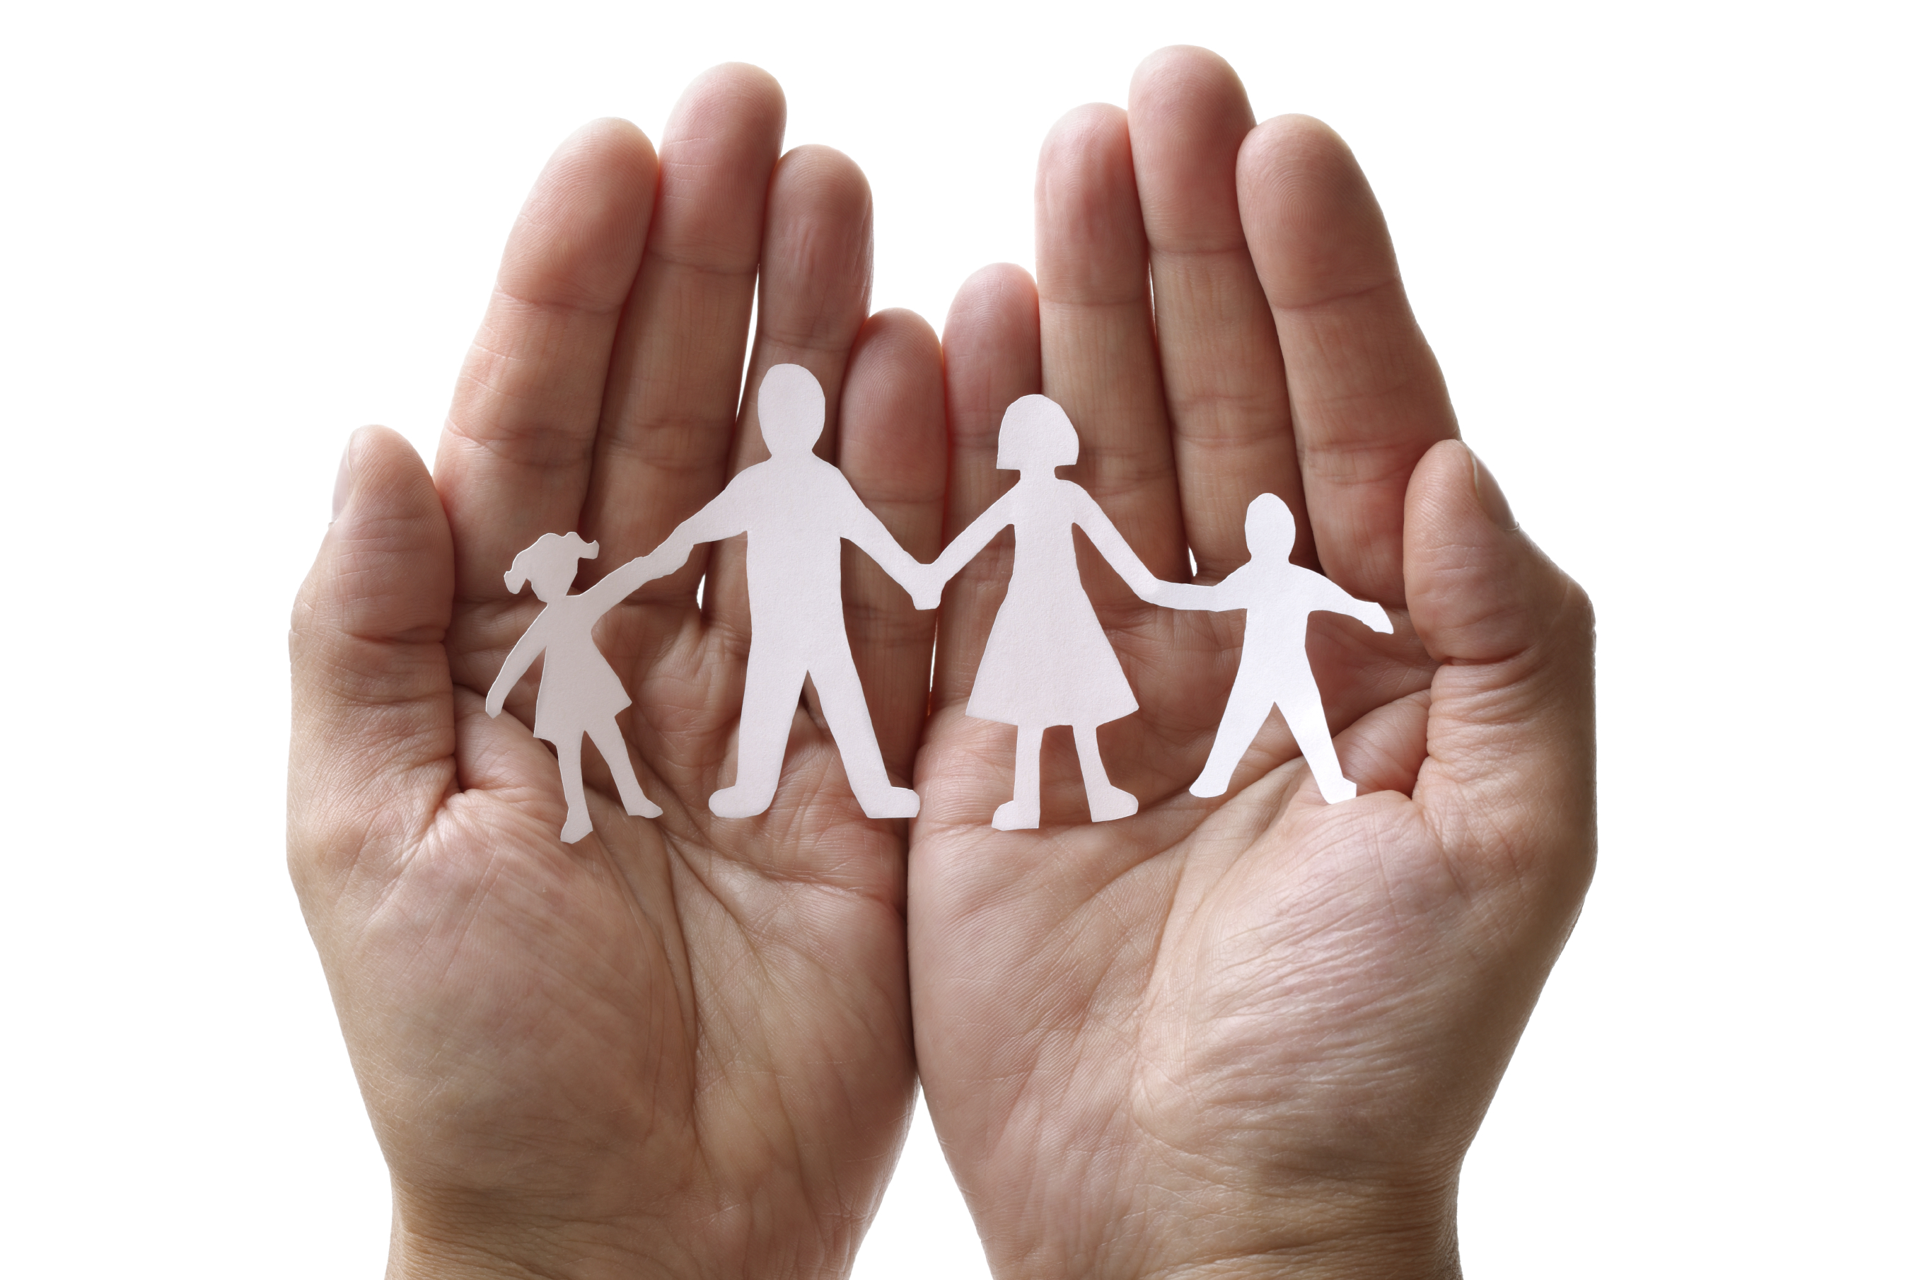
Family-to-Family Communities Project (F2FC)

Connecting Families of Individuals with Deaf-Blindness during the COVID-19 Pandemic

Virtual drop-in meetings for Parents, Guardians, and other Family Members of Individuals with Deaf-Blindness to connect with others who understand your unique perspective in coping with the COVID-19 pandemic.

Any family member of an individual with deaf-blindness is welcome to participate.
You do not need to be previously registered with F2FC.

Wednesday Afternoons | Wednesday Evenings
3pm EDT/2pm CDT/1pm MDT/12pm PDT&MST | 7pm EDT/6pm CDT/5pm MDT/4pm PDT&MST
90 minutes | 90 minutes
April 22, May 6, May 20 | April 29, May 13, May 27
https://zoom.us/j/97877958641  Meeting ID: 978 7795 8641  +1 646 558 8656 | https://tsbvi.zoom.us/j/5122069423  Meeting ID: 512 206 9423  +1 786 635 1003 or +1 971 247 1195 or +1 669 900 6833 or +1 720 928 9299

We will meet online in Zoom; however, if you need to join by phone-only, call the number listed above.

Questions??? Contact Carol Darrah, F2FC Coordinator, by email: cdarrah@uga.edu

F2FC is a collaborative project sponsored by State Deaf-Blind Projects, the National Center on Deaf-Blindness, and the National Family Association for Deaf-Blind.

