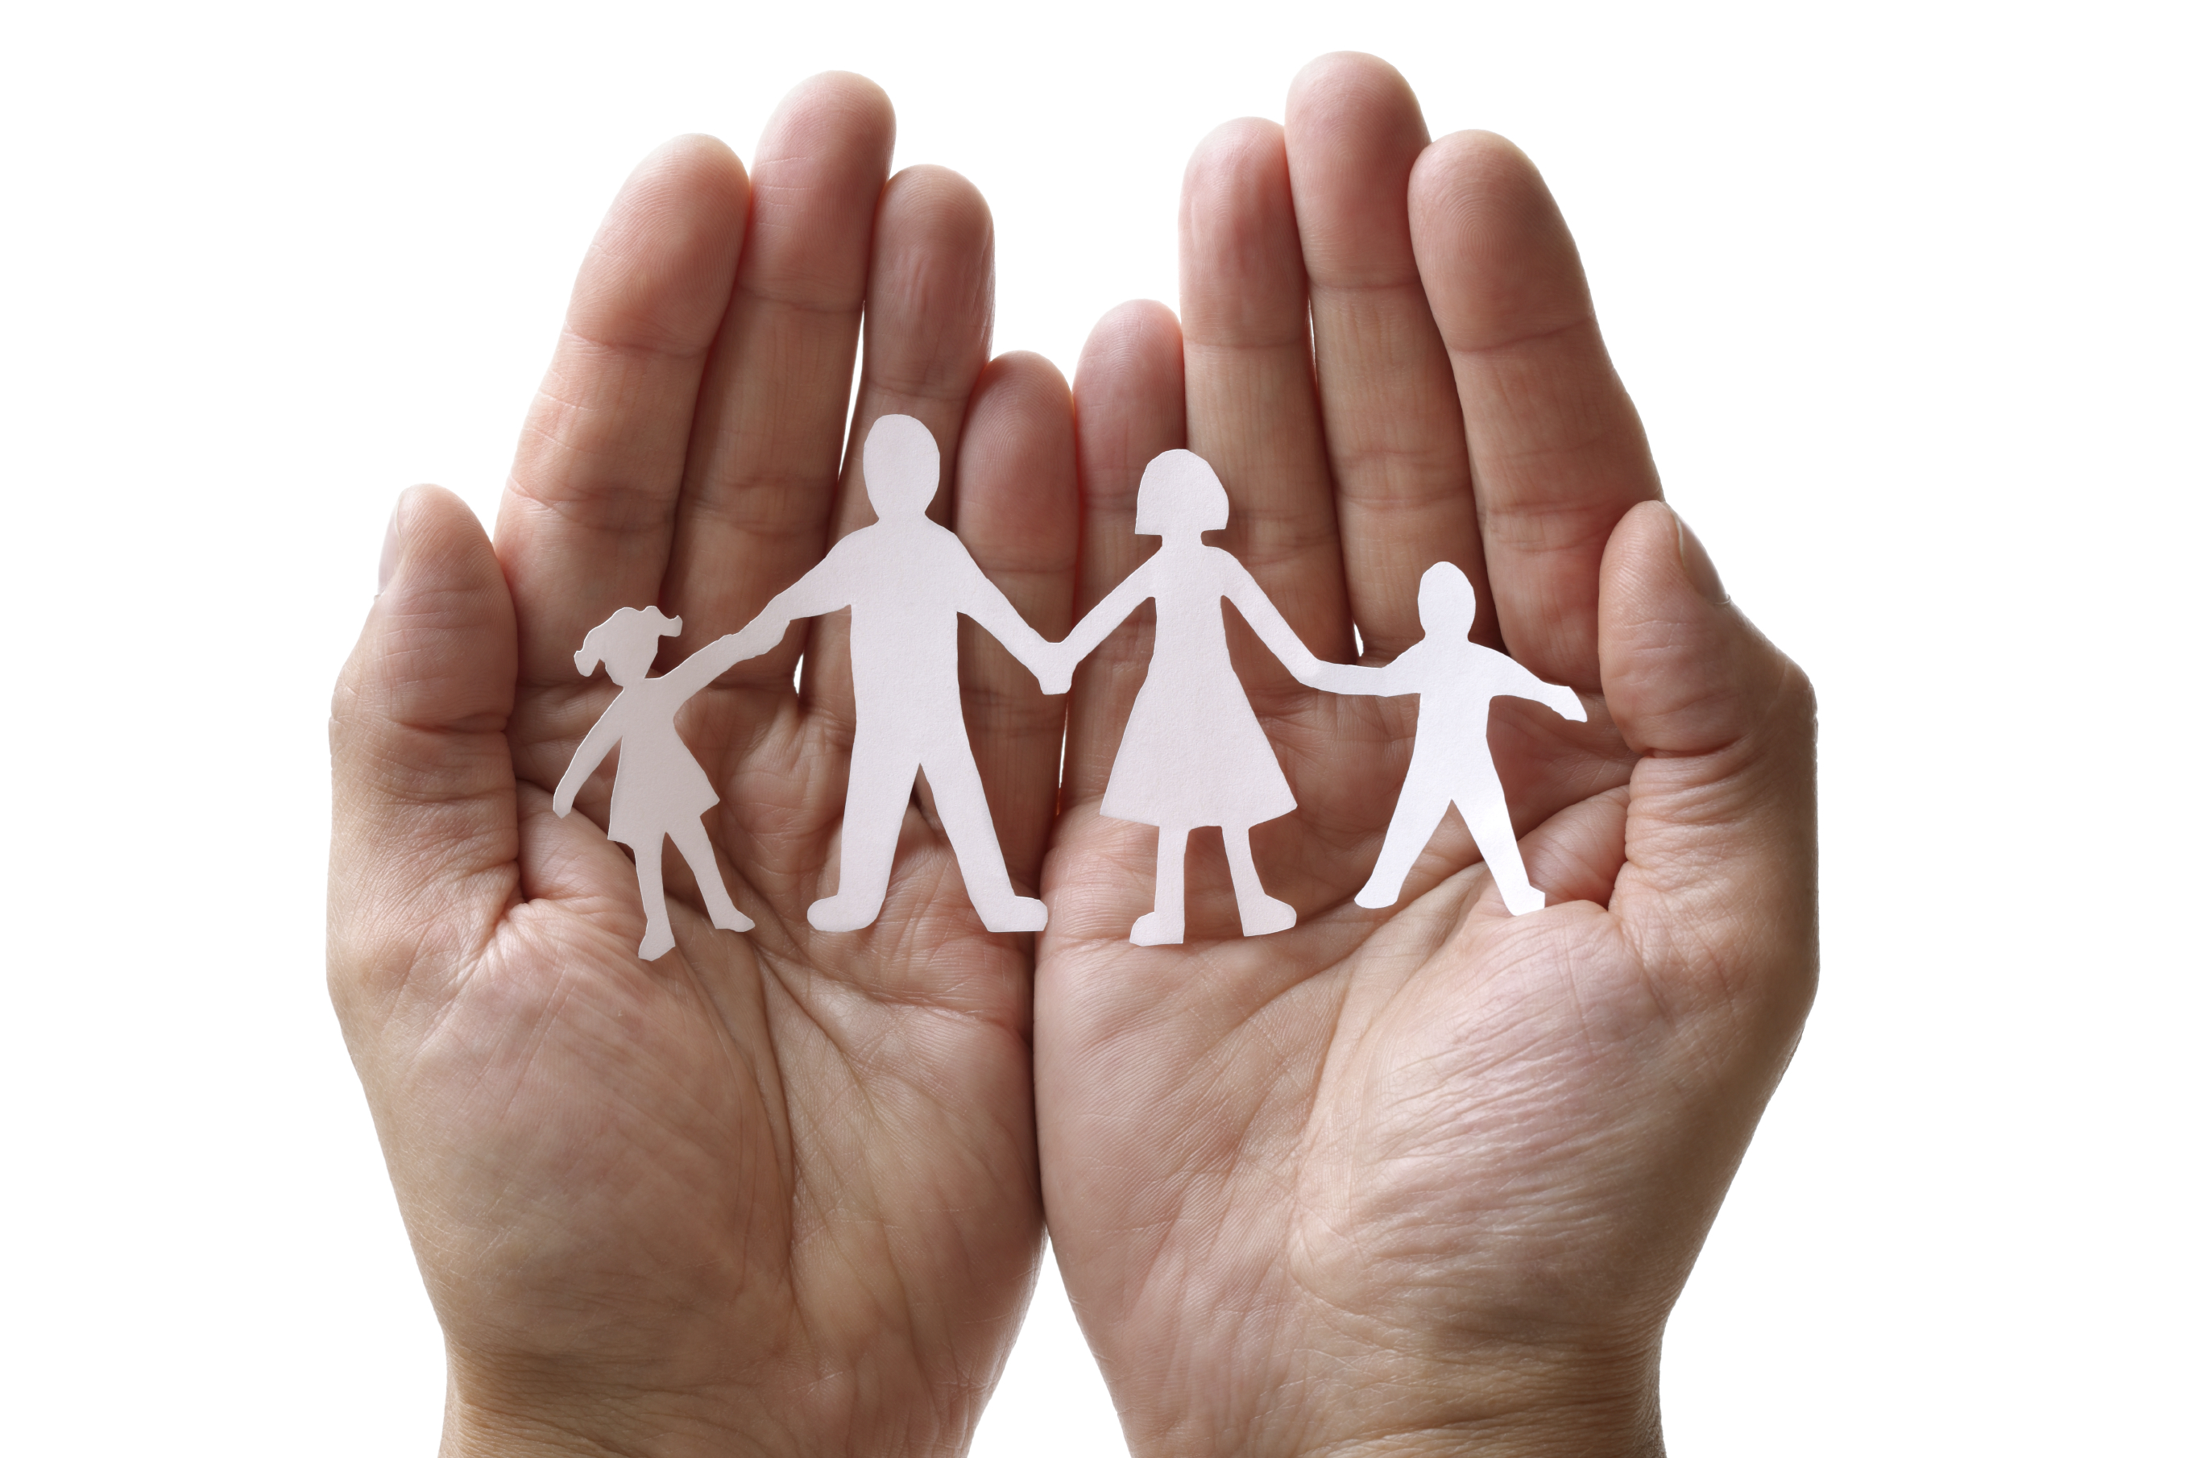
Family-to-Family Communities Project (F2FC)

Connecting Families of Individuals with Deaf-Blindness during the COVID-19 Pandemic

SUMMER DATES ADDED!
August meetings will focus on topics related to education

Virtual drop-in meetings for Parents, Guardians, and other Family Members of Individuals with Deaf-Blindness to connect with others who understand your unique perspective in coping with the COVID-19 pandemic.

Any family member of an individual with deaf-blindness is welcome to participate.
You do not need to be previously registered with F2FC.

Tuesday Afternoons
3pm EDT/2pm CDT/1pm MDT/12pm PDT&MST for 90 minutes
June 9, July 7, August 4
https://zoom.us/j/92439097657
Meeting ID: 924 3909 7657
+1 646 558 8656

Wednesday Evenings
7pm EDT/6pm CDT/5pm MDT/4pm PDT&MST for 90 minutes
June 24, July 29, August 12
https://tsbvi.zoom.us/j/5122069423
Meeting ID: 512 206 9423
+1 786 635 1003 or +1 971 247 1195 or +1 669 900 6833 or +1 720 928 9299
TSBVI Zoom requires participants to have a Zoom Acct; it’s free to create one at https://zoom.us

We will meet online in Zoom; however, if you need to join by phone-only, call the number listed above.

Questions??? Contact Carol Darrah, F2FC Coordinator, by email: cdarrah@uga.edu

F2FC is a collaborative project sponsored by State Deaf-Blind Projects, the National Center on Deaf-Blindness, and the National Family Association for Deaf-Blind.

