Family-to-Family Communities (F2FC)
Connecting Families of Individuals with Deaf-Blindness
via Distance Technology

To Extended Family Members of Families of Individuals with Deaf-blindness!

Parenting a child with deaf-blindness is unique, complex, and challenging work! As an extended family member, we believe you have a unique, complex, and challenging job in your desire to support your loved ones facing the world of dual sensory impairment.

- Are you open to learning more about deaf-blindness and the impact this has on parents?
- Are you open to learning from other extended family members how they support their loved ones?
- Are you open to sharing with other extended family members what your perspective is and how you support your loved ones?

As an extension of our Family-to-Family Communities Project, we are offering an opportunity for extended family members of families of individuals with deaf-blindness to meet via tele or video conference on a monthly basis, beginning September 2021 and ending May, 2022.

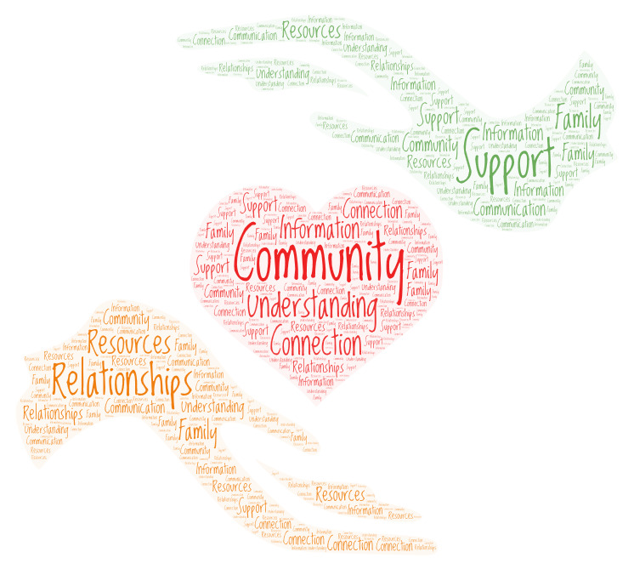

Topics will focus on understanding the impact of having a child with deafblindness and other disabilities and learning from each other how extended families can support their loved ones.

Registration:
https://tinyurl.com/F2FC2021

Questions:
Contact Jana Villemez
501-680-1294 jana.villemez@ade.arkansas.gov

